Two-Way Tables and Tree Diagrams
Question 1
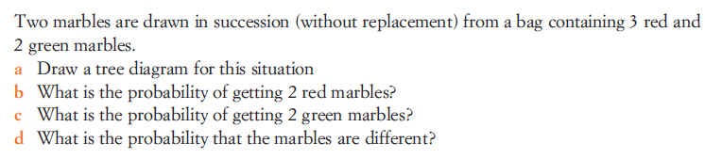

a.

b.

c.

d.

Question 2
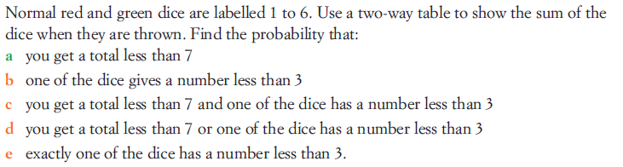

a.

b.

c.

d.

e.

Question 3.
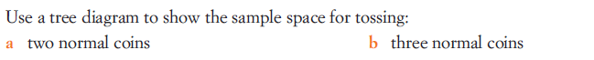
a.

b.

Question 4.
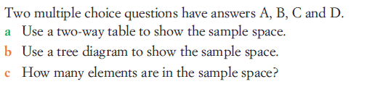
a.

b.

c.

Question 5.
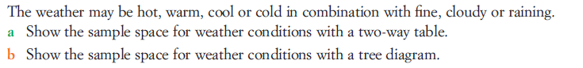
a.

b.

